
NARROGIN SENIOR HIGH SCHOOL

Capitalism – the American Experience
Unit 1: Understanding the Modern World

PRACTICE EXAMINATION 2019

Question/Answer Booklet

MODERN HISTORY
Name: __________________________
WRITTEN PAPER

Section 1  Source Analysis 1, Unit 1 | Section 2  Essay 1,  Unit 1 | Section 3  Essay 2,  Unit 1 | Section 4  Source Analysis 2, Unit 1 | Your Total
/25 | /25 | /25 | /25 | /100

Time allowed for this paper
Reading/planning time before commencing work: Ten minutes
Working time for paper: Three hours

Material required/recommended for this paper

To be provided by the supervisor
This Question/Answer Booklet
History Document Booklet

To be provided by the candidate
Standard items: Pens, pencils, eraser or correction fluid, highlighter and ruler.

Important note to candidates
No other items may be taken into the examination room. It is your responsibility to ensure that you do not have any unauthorised notes or other items of a non-personal nature in the examination room. If you have any unauthorised material with you, hand it to the supervisor before reading any further.

Structure of this paper

Section | Number of questions available | Number of questions to be answered | Suggested working time  (minutes) | Marks available | Percentage of exam
Section 1:  Source Analysis 1 | 1 | 1  (a-e) | 45 | 25 | 25
Section 2:  Essay One | 3 | 1 | 45 | 25 | 25
Section 3:  Essay Two | 3 | 1 | 45 | 25 | 25
Section 4: Source Analysis 2 | 1 | 1  (a-e) | 45 | 25 | 25
Total |  |  | 100

Instructions to candidates

- The rules for the conduct of examinations are detailed in the handout with your individual student timetable. Sitting this examination implies that you agree to abide by these rules.

- Write your answers in this Question/Answer Booklet provided.

- You are to answer ALL of Section One Source Analysis Set 1.

- You are to answer ONE question from Section Two (Essay 1)

- You are to answer ALL of Section Three Source Analysis Set 2.

- You are to answer ONE question in Section Three (Essay 2).

SECTION ONE: SOURCE ANALYSIS SET 1, Unit 1

This section has ONE question made up of FIVE (5) parts. Attempt ALL parts. Write your answers in the spaces provided.

- The marks allocation for this section is 25 marks.

- Allow approximately 45 minutes for this section.

Suggested working time: 45 minutes.

Question 1

- Compare and contrast the messages in Source 1 and 2.
(4 marks)

(b) Evaluate the usefulness of Source 1 and 2 as representations of attitudes regarding America’s involvement in World War Two. (5 marks)

(c) Explain the historical context of Source 3. (4 marks)

(d) Identify and account for the authors’ perspectives in Sources 3 and 4, regarding America’s involvement in World War Two. (6 marks)

(e) Evaluate the extent to which the four sources give an accurate insight into attitudes regarding America’s involvement in World War Two. (6 marks)

END OF SECTION ONE

SECTION TWO: ESSAY ONE, UNIT 1

- This section has THREE (3) questions. Attempt ONE (1) question only.
- The marks allocation for this section is 25 marks.
- Allow approximately 45 minutes for this section.
- Begin each essay on a new page

Pages are included from page 11 of this booklet for planning and writing your answer.

● Planning: If you use the pages for planning, indicate this clearly at the top of the page.
● Answering the question: In the pages provided indicate clearly the question number you are
answering.

Indicate below the elective you will use to respond to this question.
Elective 1: □ Capitalism – the American Experience

Suggested working time: 45 minutes.

In your answers, you must use a range of examples from the time period you studied.

REMEMBER TO ANSWER ONLY ONE OUT OF THE FOLLOWING THREE ESSAYS

Question 1

Analyse the political response to the Great Depression in America.

OR

Question 2

Evaluate the role and impact of Woodrow Wilson as a wartime leader.

OR

Question 3

Assess the extent of change experienced by women in America during the 1920s.

USE THE PAGES AT THE END OF THE THIS BOOKLET FOR YOUR ANSWERS.
CLEARLY INDICATE THE NUMBER OF THE QUESTION ON WHICH YOU ARE WORKING.

END OF SECTION TWO

SECTION THREE: ESSAY TWO, UNIT 1

- This section has THREE (3) questions. Attempt ONE (1) question only.
- The marks allocation for this section is 25 marks for each question answered.
- Allow approximately 45 minutes for this section.
- Begin each essay on a new page

Indicate below the document set from the Document Booklet you will use to respond to this
question.

Elective 1: □ Capitalism – the American Experience

In your answers, you must use a range of examples from the time period you studied.

REMEMBER TO ANSWER ONLY ONE OUT OF THE FOLLOWING THREE ESSAYS

Question 4

Identify at least one economic initiative implemented in America during the Progressive era and analyse its impact on American society.

OR
Question 5

Assess the significance of one key individual of the time period.

OR
Question 6

Assess the extent of change experienced by immigrants in America during the time period.

USE THE PAGES AT THE END OF THE THIS BOOKLET FOR YOUR ANSWERS.
CLEARLY INDICATE THE NUMBER OF THE QUESTION ON WHICH YOU ARE WORKING.

REMEMBER TO CLEARLY IDENTIFY ANY ROUGH WORKING.

END OF SECTION THREE
SECTION FOUR: SOURCE ANALYSIS SET 2, Unit 1

This section has ONE question made up of FIVE (5) parts. Attempt ALL parts. Write your answers in the spaces provided.

- The marks allocation for this section is 25 marks.

- Allow approximately 45 minutes for this section.

Indicate below the document set from the Document Booklet you will use to respond to this
question.

Set 1: □ Capitalism – the American Experience 1907-1941

- Compare and contrast the messages of Sources 1 and 2. (4 marks)

- Evaluate the usefulness of Sources 1 and 2 as representations of the attitudes towards changes in the USA in the 1920s. (5 marks)

- Explain the historical context of Source 3. (4 marks)

(d) Identify and account for the authors’ perspectives in Sources 3 and 4 regarding the specific changes described in the documents. (6 marks)

(e) Using your knowledge of the whole period of study, evaluate the importance of the
themes, ideas and/or events represented in the four sources. (6 marks)

END OF SECTION FOUR

Question number:

Question number:

Question number:

Question number:

Question number:

Question number:

Question number:

Question number:

Question number:

Question number:

SOURCE ANALYSIS SET 1, Unit 1

Source 1: President Franklin D. Roosevelt, December 8, 1941

"No matter how long it may take us to overcome this premeditated invasion, the American people in their righteous might will win through to absolute victory."

Source 2: An American propaganda poster, circa 1940s.
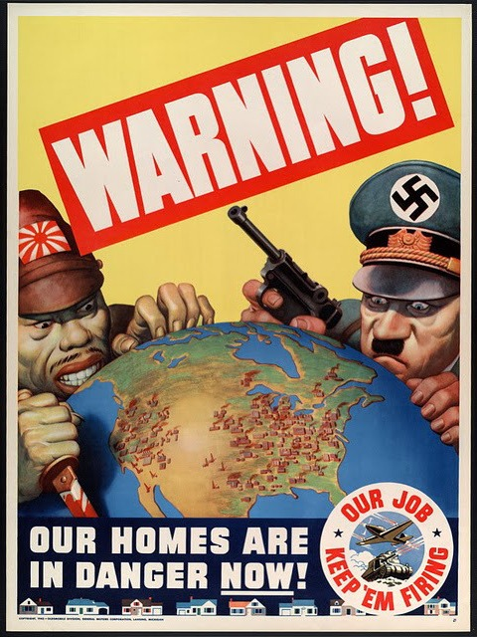

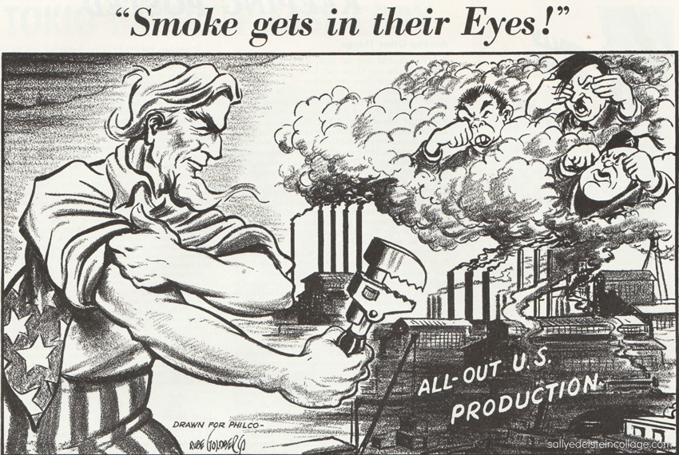
Source 3: A political cartoon titled, Smoke gets in their eyes! 1942.

Source 4: An excerpt of a quote by Elliot Johnson, an American soldier in World War Two, from the book written by historian Studs Terkel, The Good War: An Oral History of World War II, 1984.

“I am totally averse to killing and warfare. I saw it with my own eyes and it didn’t do a dratted thing. And the wonderful boys we lost over there. It took four years out of my life.”

SOURCE ANALYSIS SET 2, Unit 1

Source 1: Published in an American newspaper, June 1922, captioned, “Mothers Gravely Concerned with Saving Their Sons from Her Predatory Clutches.”

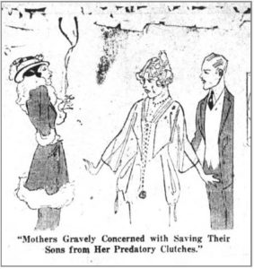

Source 2: An excerpt from an article titled ‘Her Eternal Youth’ published in the New York Times on July 2nd, 1922.
There is nothing secretive about the modern girl. The planks in her platform are frankness, common sense and comfort. She refuses to wear uncomfortable clothes because her grandmother considers them ladylike. When conventions interfere with comfort, conventions must go, assert the flapper. Her teachers and professors give her credit for sense and decision. They tell you she is neither bad, nor is she different from the young of other years.

Source 3: A poster showing two children standing outside a saloon, was issued by the Anti-Saloon League. It first appeared in the Chicago Sun Times. The caprion reads, “Daddy’s in there – And Our Shoes and Stockings and Clothes and Food Are in There, Too, and They’ll Never Come out.”
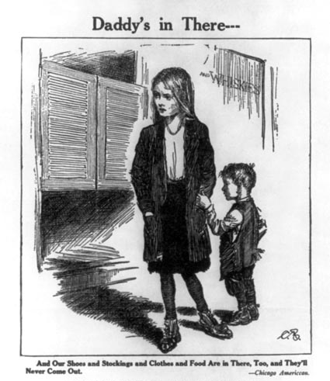

Source 4: A political cartoon published in the Chicago Daily Tribune, April 29th 1926.
